Section : B

Name :Muhammad usama.

Roll no :17f-8915:

Task 1:

#include<iostream>

using namespace std;

int dispaly(int n);

int main()

{

int n=0;

cout<<"enetr any no of which you want to see all previous no by using recursion"<<endl;

cin>>n;

dispaly(n-1);

cout<<endl;

system("pause");

return 0;

}

int dispaly(int n)

{

cout<<n<<" ";

if(n==1)

{

return 0;

}

dispaly(n-1);

return 0;

}

Result:

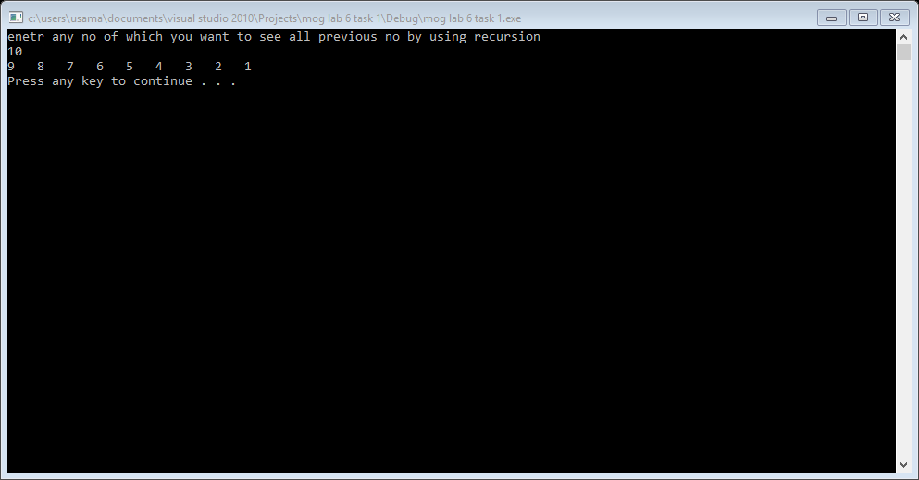

Task 2:

#include<iostream>

using namespace std;

bool prime(int n, int h);

int main()

{

int n=0,h=0,c=0;

cout<<"enetr any no"<<endl;

cin>>n;

h=n;

if(n==1)

{

cout<<"not a prime no"<<endl;

system("pause");

return 1;

}

else if (n==2)

{

cout<<"prime no "<<endl;

system("pause");

return 1;

}

bool flag= prime(n,h-1);

if(flag==true)

cout<<"Prime no"<<endl;

else

cout<<"Not prime no"<<endl;

system("pause");

return 0;

}

bool prime(int n,int h)

{

if (h==1)

return true;

if(n%h==0)

{

return false;

}

prime(n,h-1);

}

Result:

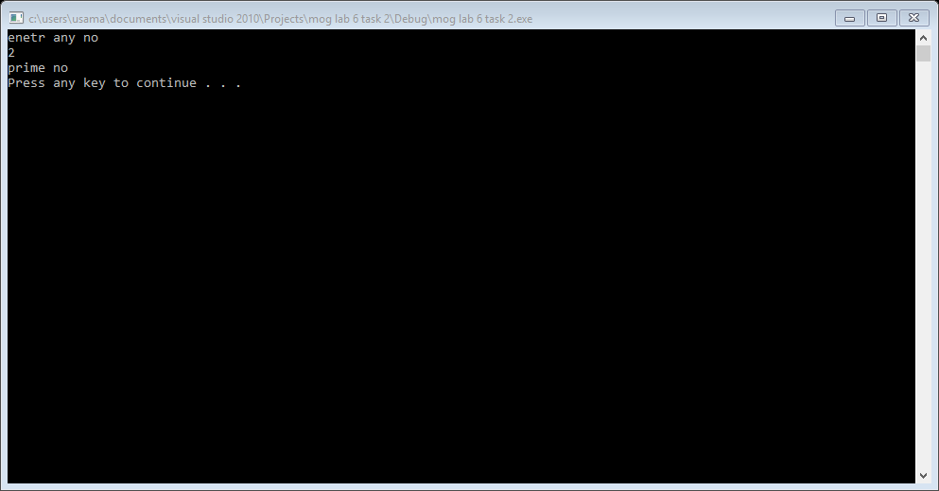

Task 3:

#include<iostream>

using namespace std;

bool prime(int n, int h);

int print(int n);

int main()

{

int n=0,h=0,c=0;

cout<<"enetr any no : ";

cin>>n;

if(n==1)

{

cout<<"not a prime no"<<endl;

system("pause");

return 1;

}

else if (n==2)

{

cout<<"prime no "<<endl;

system("pause");

return 1;

}

print(n);

system("pause");

return 0;

}

bool prime(int n,int h)

{

if (h==1)

return true;

if(n%h==0)

{

return false;

}

prime(n,h-1);

}

int print(int n)

{

if(n==1)

{

return 0;

}

if(prime(n,n-1))

{

cout<<n<<endl;

}

print(n-1);

}

Result:

